# Deploy the Polls app to Heroku:

By Marvin, Feb/23/2020

Getting started on Heroku with Python: <https://devcenter.heroku.com/articles/getting-started-with-python#prepare-the-app>

1. Go py_django2\web_project (my project folder), and run pip freeze > requirements.txt
2. Push files to github repo: <https://github.com/marvinxu99/py_django2.git>
3. Go to pythonanywhere.com, create a beginner’s account at <https://www.pythonanywhere.com/>

User: winnpy/mxx.2xxx

1. Launch a Bash console from PythonAnywhere

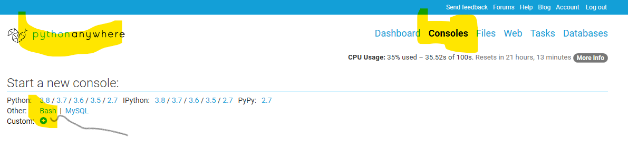

1. Run git clone <https://github.com/marvinxu99/py_django2.git> in Bash
2. run ls to confirm the folder py_django2 and files are cloned
3. cd py_python2/web_project
4. Make a virtual env for the web app (https://help.pythonanywhere.com/pages/Virtualenvs)

$ mkvirtualenv myvirtualenv --python=/usr/bin/python3.8

1. $ which python

/home/winnpy/.virtualenvs/myvirtualenv/bin/python

1. $ workon myvirtualenv, to use the venv if needed
2. $ pip install -r requirements.txt . it should install Django 3.0.2 and other packages.
3. $ python manage.py migrate – to create all the sqlite3 database tables needed for auth
4. Ensure the following are set in web_project\settings.py

DEBUG = False  
STATIC_ROOT = = os.path.join(BASE_DIR, 'static_collected')

1. collect static files to STATIC_ROOT:  
   $ python manage.py collectstatic

/home/winnpy/py_django2/web_project/static_collected

1. $ python manage.py createsuperuser – create super user and other users to create the site
2. Go to pythonanywhere dashboard, and create a new app:

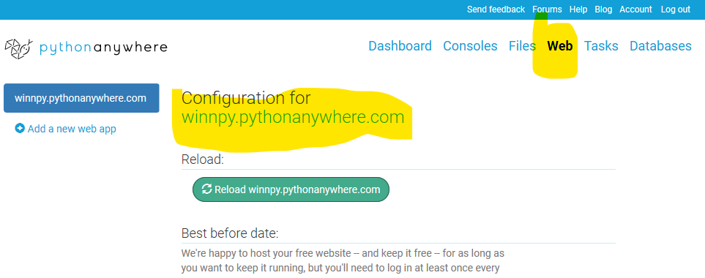

1. Select “Manual configuration” - select python3 + Django
2. Set up the folders information for the app:

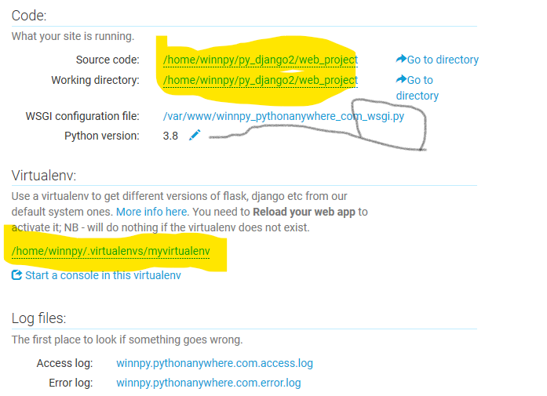

1. For the settings in winnpy_pythonanywhere_com_wsgi.py, edit the Django section accordingly, but delete or comment out all other sections.

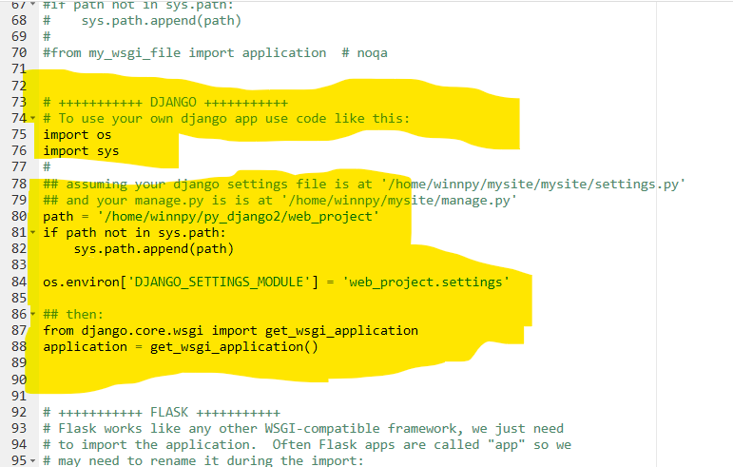

1. Also edit py_django2\web_project\web_project\settings.py.

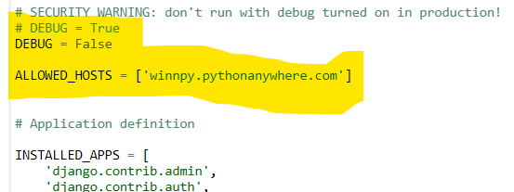

1. Reload your app, and open and enjoy it!